Run 10 - Voltage Sweep: -5 kV, 2mA, 800K particles, Deuterium

Radial Potential Profiles
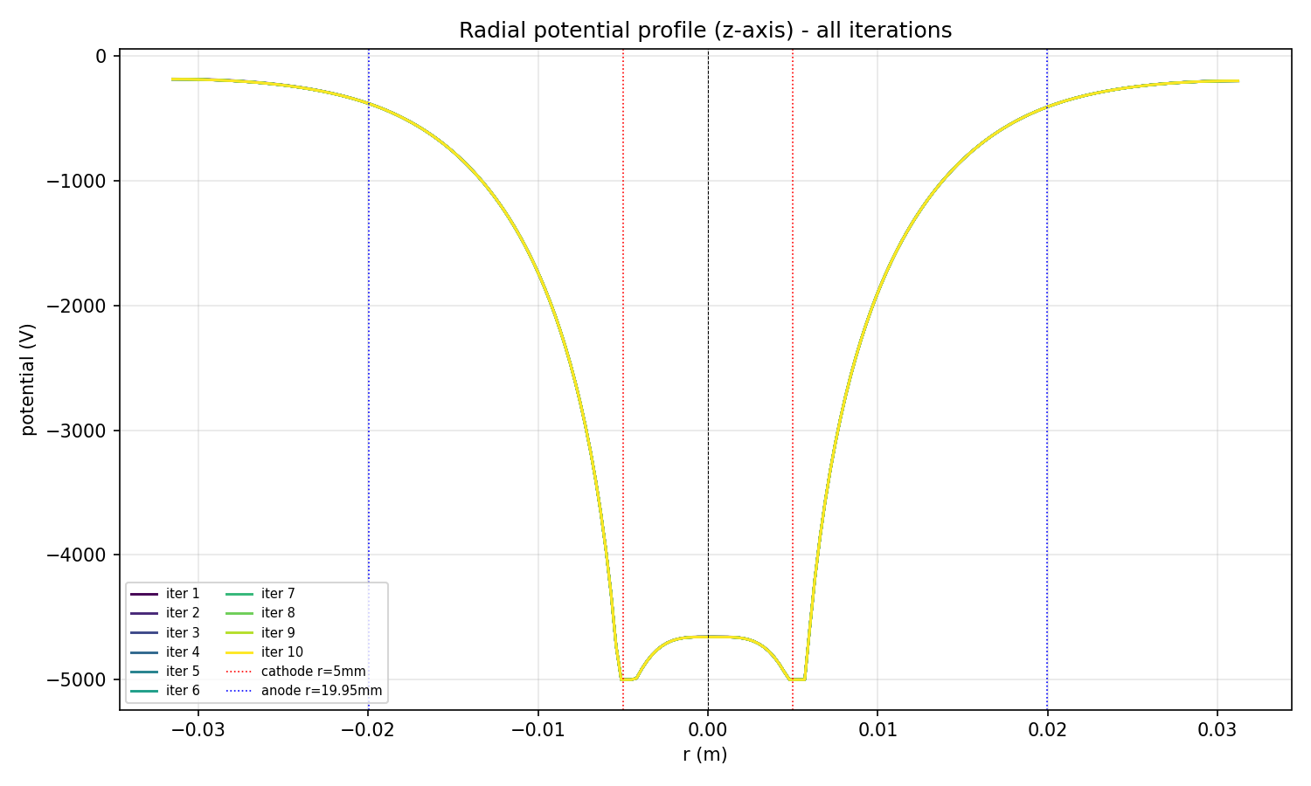
Radial potential along z-axis, all iterations overlaid

Final Potential Field
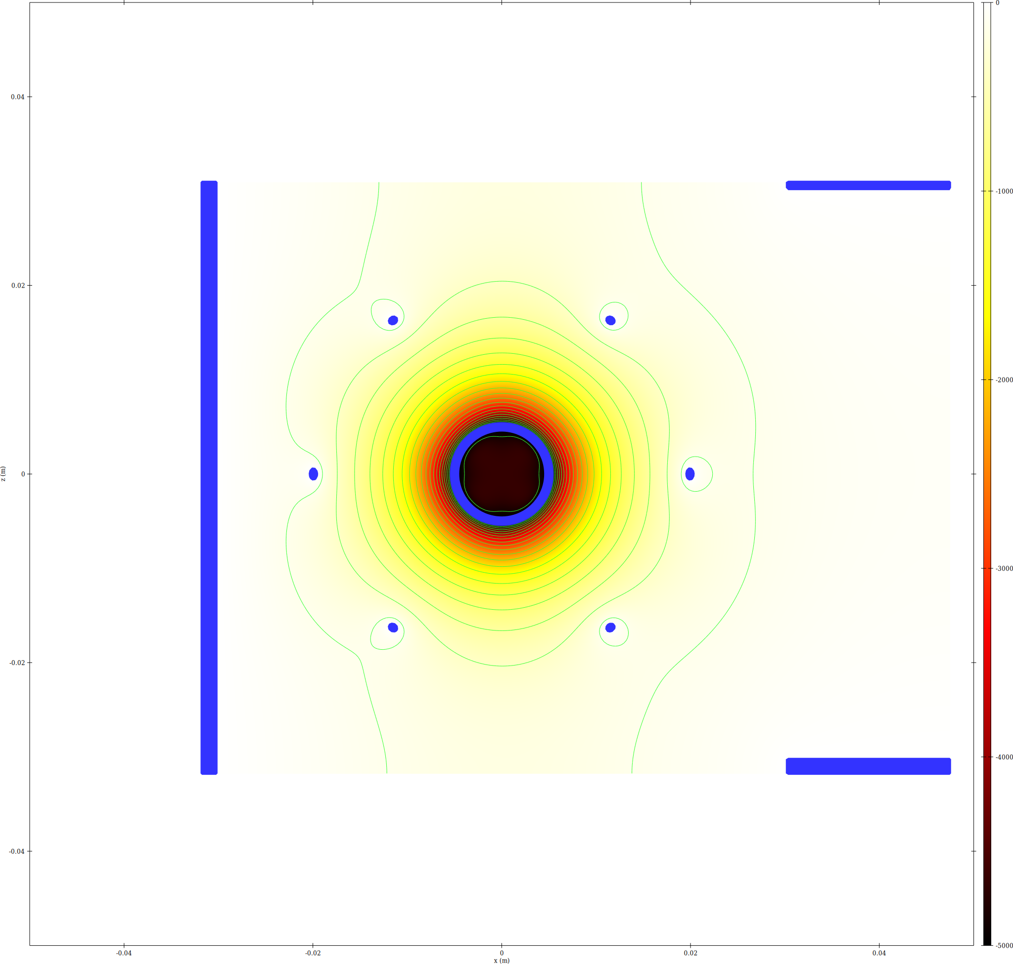
epot XZ slice
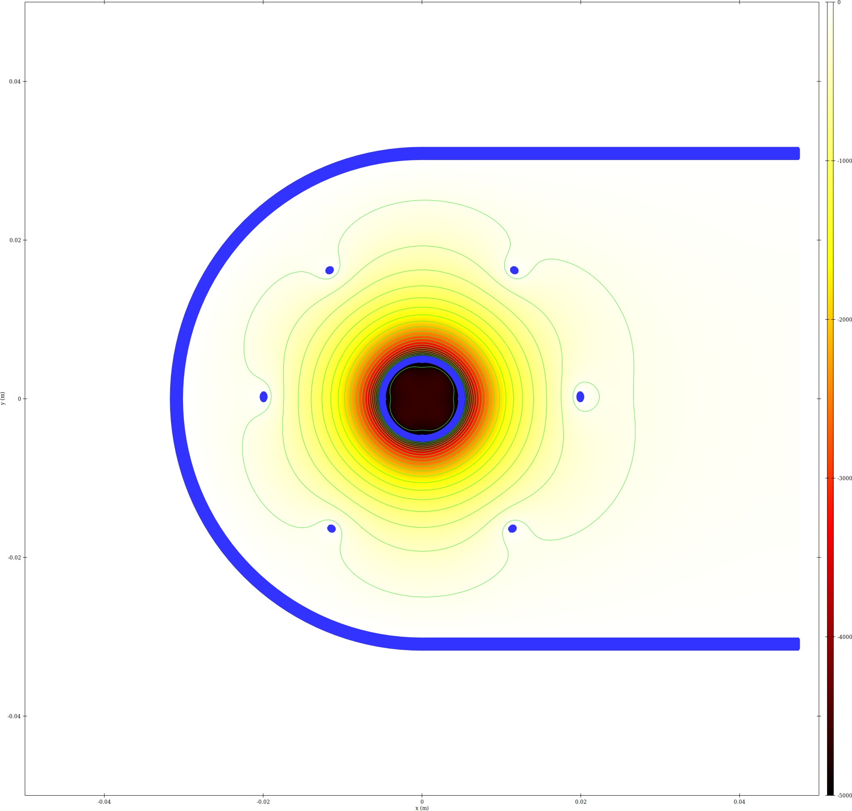
epot XY slice
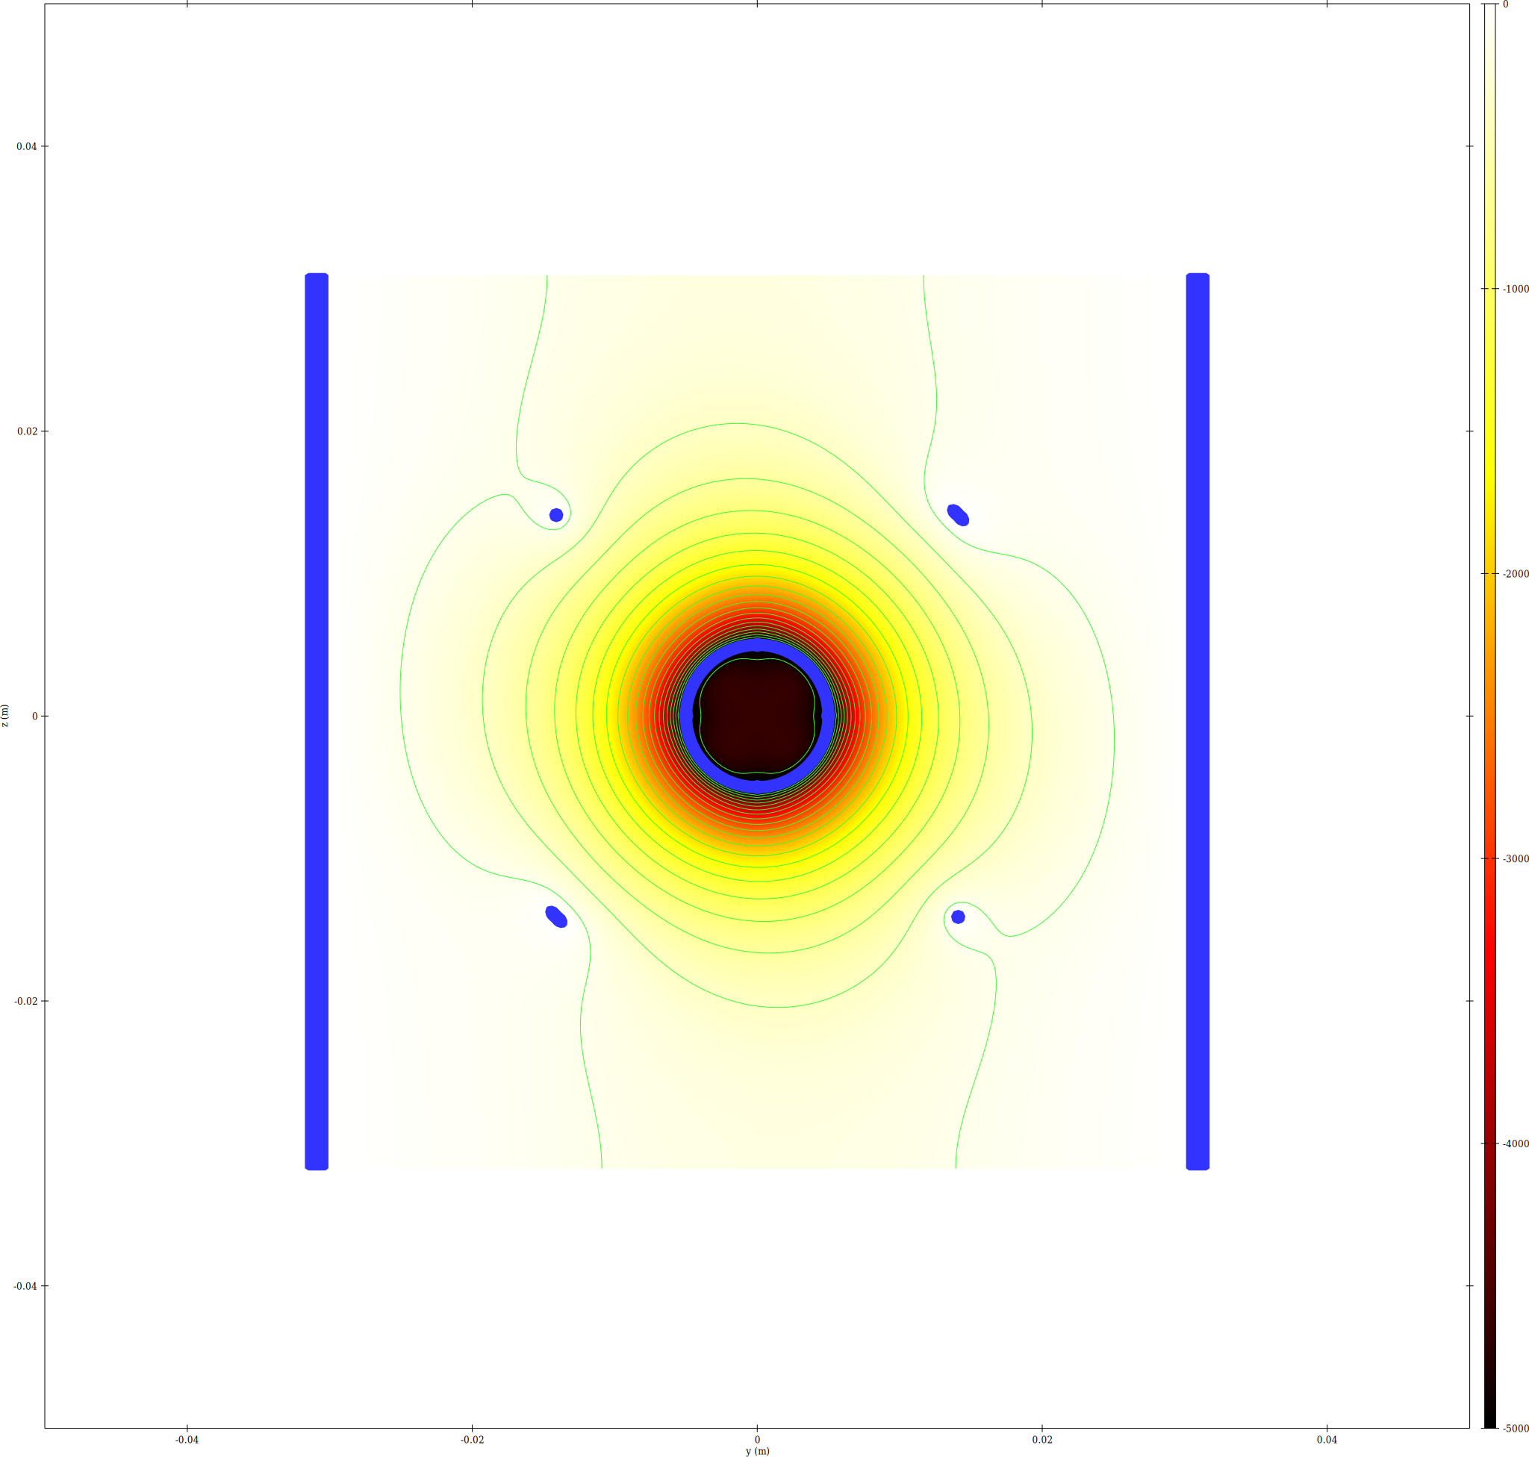
epot YZ slice at x=0

Trajectory Density
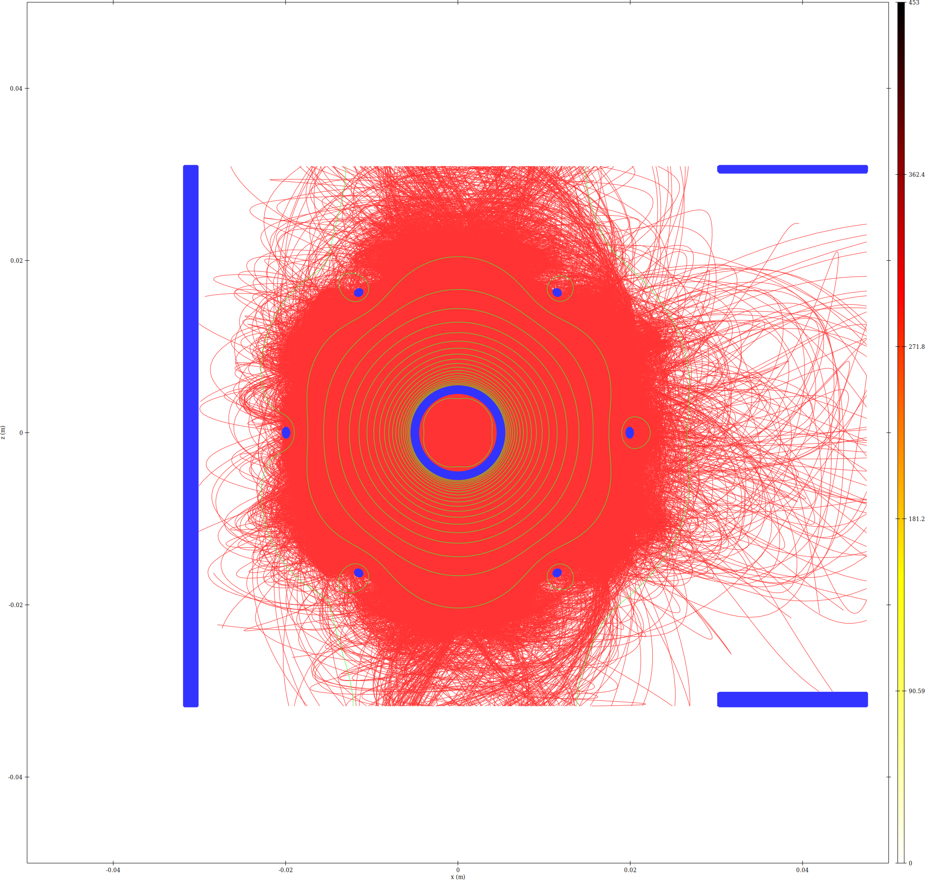
Trajectory density XZ slice
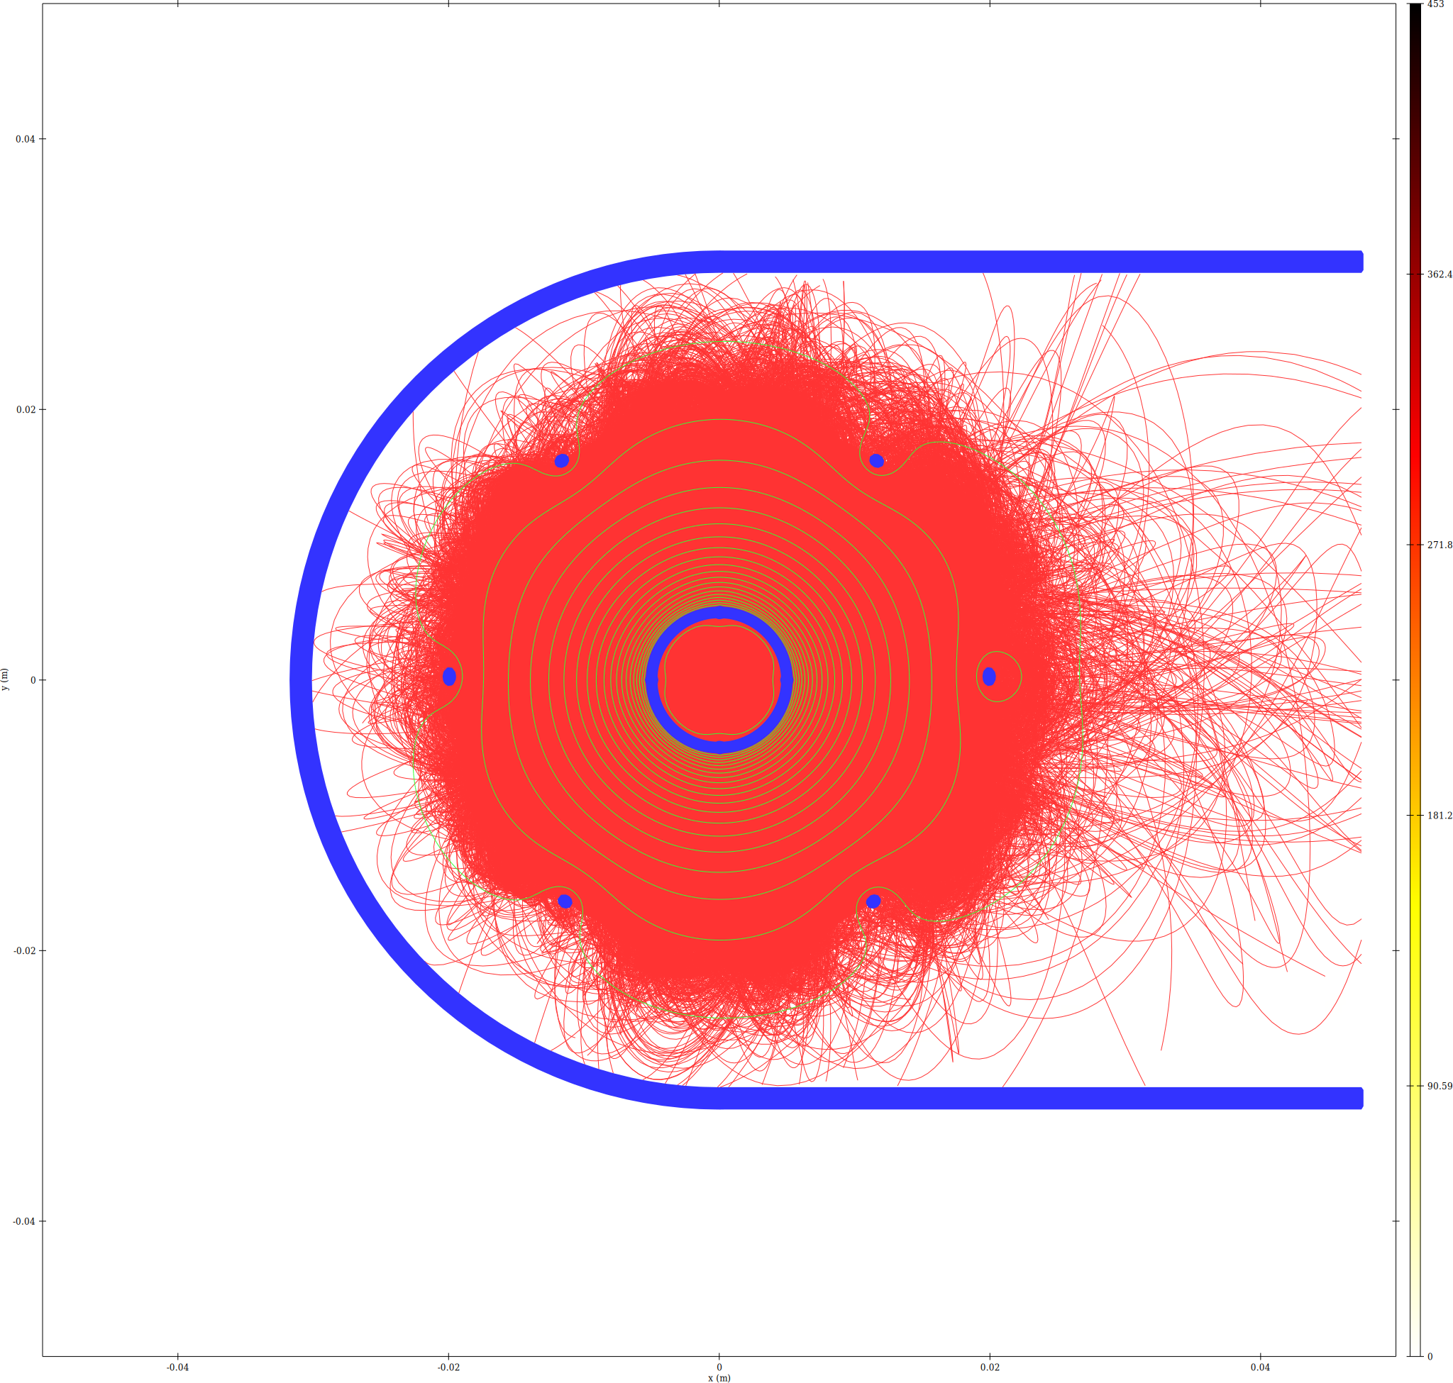
Trajectory density XY slice

Memory Estimate
iteration | total_steps | total_MB | total_GB
1 | 6908102 | 471.9293 | 0.460868
2 | 6909311 | 471.9938 | 0.460931
3 | 6939262 | 473.5934 | 0.462494
4 | 7018371 | 477.8183 | 0.466619
5 | 6931826 | 473.1963 | 0.462106
6 | 6921924 | 472.6674 | 0.461589
7 | 6942100 | 473.7450 | 0.462642
8 | 6979056 | 475.7186 | 0.464569
9 | 6929448 | 473.0693 | 0.461982
10 | 6951677 | 474.2564 | 0.463141

Convergence
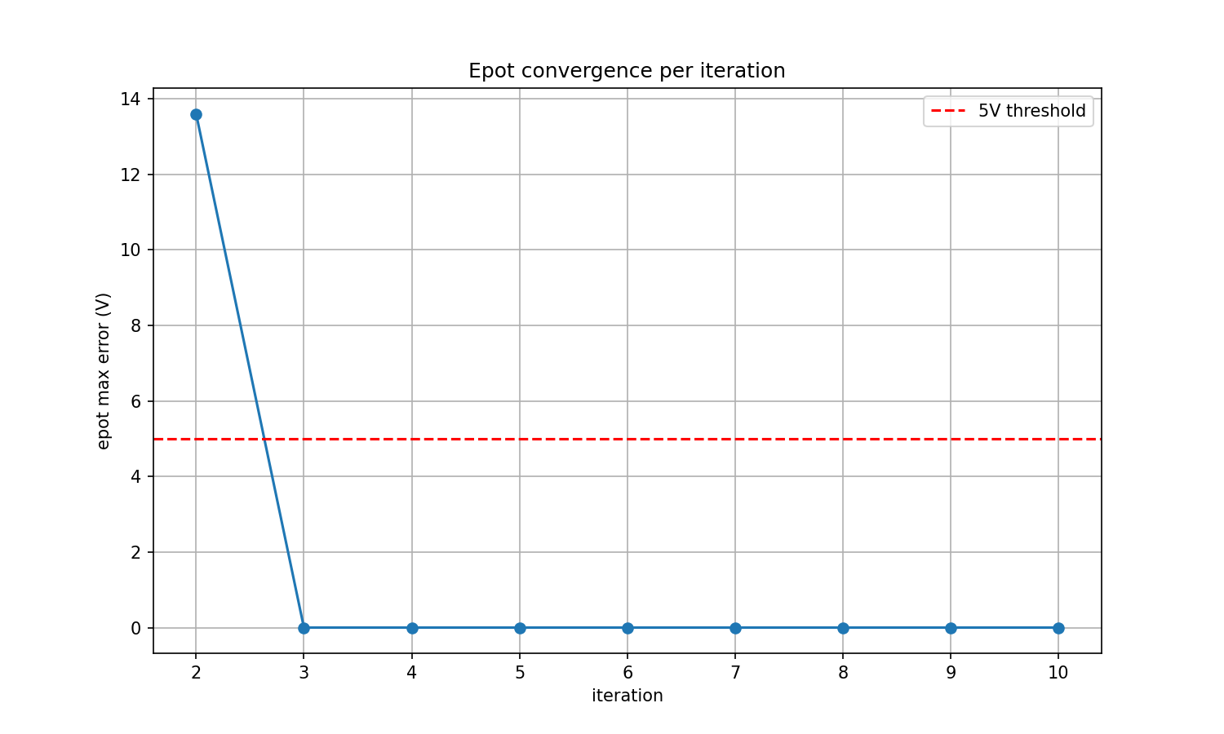
Epot max error vs iteration

